Health and Physical Education
F - Year 2 (Week 5, Term 2) Summative Assessment

Summative Assessment Task 1

Cognitive Reinforcer

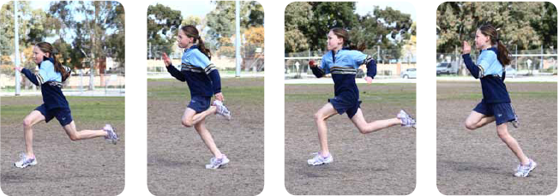

From: Pill, S (2015) Play with purpose: For Fundamental Movement Skills Teaching: A teaching guide for early years and primary educators for physical education and daily PE. Kent Town, SA: ACHPER (SA).
Look at the picture of the girl sprinting.

List below some of the games you play that involve sprinting.

What do you need to remember to sprint as fast as you can?

Adapted from: Fundamental movement skills: Book 2 - The tools for learning, teaching and assessment, Department of Education WA 2013 p106

Summative Assessment Task 2

Cognitive Reinforcer

Skill: Sprint Run and Vertical Jump
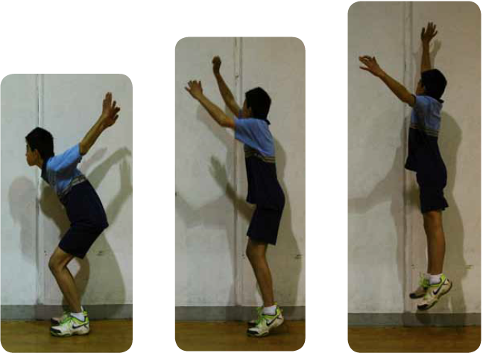

From: Pill, S (2015) Play with purpose: For Fundamental Movement Skills Teaching: A teaching guide for early years and primary educators for physical education and daily PE. Kent Town, SA: ACHPER (SA).
Look at the picture of the girl sprinting and the boy jumping.

What are some of the games or sports you play that involve running and jumping?

What do you need to remember to run and then jump?

Adapted from: Fundamental movement skills: Book 2 - The tools for learning, teaching and assessment, Department of Education WA 2013 p106

Summative Assessment Task 3

Encouraging Questions with a Partner

Skill: Sprint Run and Vertical Jump

Ask your partner the following questions about the games you played and how you feel about running and jumping.

What happened in the game(s) you played today?

Why did this happen?

What surprised you in the game?

What was fun?

How confident are you to run and jump in games?  Why do you place yourself here?? | Not Confident Confident Very Confident  I__________________________I______________________I

Adapted from: Fundamental movement skills: Book 2 - The tools for learning, teaching and assessment, Department of Education WA 2013 p108

Summative Assessment Task 4

Observation Checklists

Skills: Sprint Run and Vertical Jump

Teacher: Class Student

Skill: Sprint Run
Skill Video: https://www.youtube.com/watch?v=9pEDMCL9AJw
Element | Always | Sometimes | Rarely
Eyes are focussed forward while running

Knees bend at right angles during the drive

Arms bend at elbows and move opposite to legs

Arms swing forward and not across the body

Leg extends during the push

The body leans slightly forward

Hands and fingers positioned correctly (relaxed)

Landing on the balls of the feet

Comment:

From: Pill, S (2015) Play with purpose: For Fundamental Movement Skills Teaching: A teaching guide for early years and primary educators for physical education and daily PE. Kent Town, SA: ACHPER (SA). p. 86

Skill: Vertical Jump
Element | Always | Sometimes | Rarely
Eyes are focussed forward throughout the jump

Crouch by bending at the knees

During crouch the arms swing back behind the body

Upward movement occurs with a forceful extension of the legs and forward swing of the arms

Arms extend upwards above the body and the arms straighten as the legs straighten

On landing the knees bend to absorb the impact

On landing the feet initially contact the ground with the balls of the feet

Comment:

From: Pill, S (2015) Play with purpose: For Fundamental Movement Skills Teaching: A teaching guide for early years and primary educators for physical education and daily PE. Kent Town, SA: ACHPER (SA). p. 91

© Australian Council for Health, Physical Education and Recreation, SA Branch Inc. ACHPER SA 2020.
Please note that the materials below are the intellectual property of ACHPER South Australia, unless otherwise stated. Use is provided for education purposes only, this includes ACHPER Members and internal School usage. Unauthorised copying or sharing of this material is contrary to copyright law.

